**Operating System Lab**

**Fall 2024**

**Lab 03 Task**



**Lab Instructor:**

**Kausar Nasreen Khattak**

**Name:Noor-ul-huda**

**Sap-id:46053**

**Lab Task**

**Q1.** Make the following directory (03 Marks)

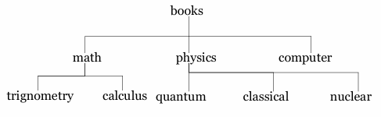

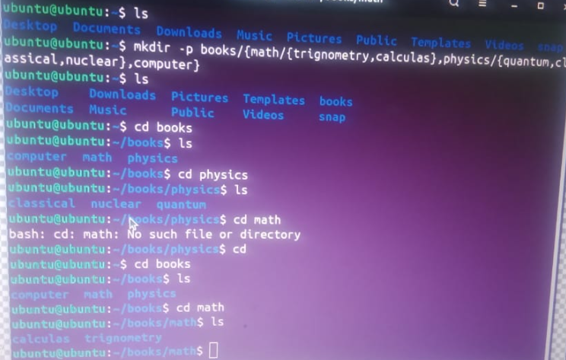

**Q2.** Which are the Linux Directory Commands? Explain the understanding of commands in your own words. Also define what is BASH? (02 Marks)

**Note:** Include screenshots, where required to illustrate your explanation.

1. **pwd (Print Working Directory):**

* **Usage:** pwd
* **Explanation:** Displays the current directory path you are in. It helps you know your exact location within the filesystem.

1. **ls(List):**

* **Usage:** ls, ls -l, ls -a
* **Explanation:** Lists the files and directories in the current working directory.

1. **cd (Change Directory):**

**Usage:** cd <directory_name>

**Explanation:** Changes the current directory to the specified one. Using cd .. will navigate up one level.

1. **mkdir (Make Directory):**

**Usage:** mkdir <directory_name>

**Explanation:** Creates a new directory with the specified name.

1. **rmdir (Remove Directory):**

**Usage:** rmdir <directory_name>

**Explanation:** Removes an empty directory. If the directory is not empty, you need to use rm -r to remove it recursively.

1. **mv (Move):**

**Usage:** mv <source> <destination>

**Explanation:** Moves or renames files and directories

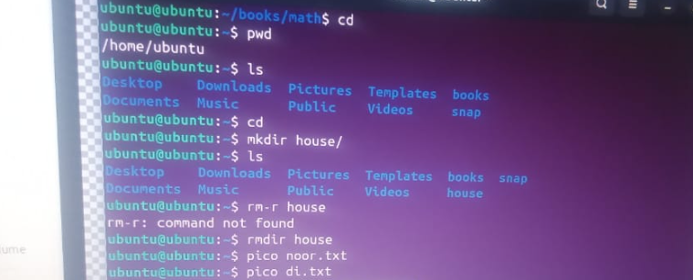

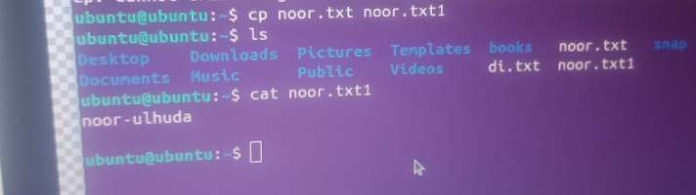

**Q3.**

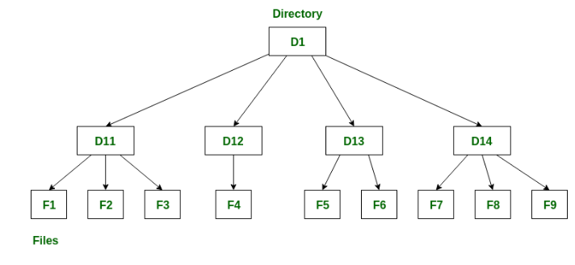

**Note:** Include screenshots, where required to illustrate your explanation. (02 Marks)

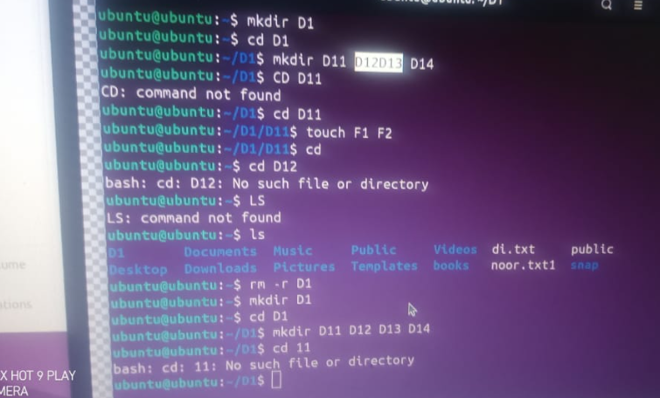

**Q4.** Make the following directory (03 Marks)

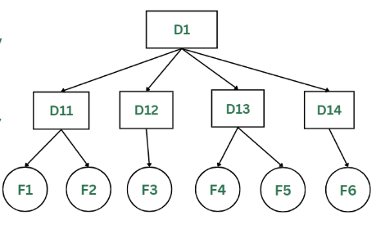

**Note:** Include screenshots, where required to illustrate your explanation.

